PROJECT 1
Anonymized data regression: model selection and diagnostics
- Univariate Analysis
- Exploratory Data Analysis (EDA)
- Bivariate Analysis
- Grouping Categorical Features
- Encoding Categorical Variables
- Train-Test Split
- Y Transformation (Box-Cox, Box-Tidwell)
- Multiple Linear Regression (Initial Model)
- Outlier Detection (after fitting the initial model): Detect and handle outliers using Cook's Distance, DFFITS, DFBETAS, and hat matrix.
- Check Assumptions (Linearity, Normality, Multicollinearity, Homoscedasticity, Autocorrelation)
- Added Variable Plots and Interaction Terms:
- Use added variable plots to identify potential interactions.
- Introduce interaction terms at this stage, based on the insights from added variable plots.
- Model Selection (Forward, Backward, Stepwise) (with interaction terms included):
- Perform model selection with the interaction terms already in the model, so the process can evaluate whether they improve performance based on criteria like AIC, BIC, or adjusted R-squared.
- Scaling
- Final Model Evaluation
~~~~~~~~~~~~~~~~~~~~~~~~~~~~~~~~~~~~~~~~~~~~~~~~~~~~~~~~~~~~~~~~~~~~~~~~~~~~~~~~~~~~~~~
Grouping categorical features is done to reduce high cardinality, making the model simpler and less prone to overfitting. It also improves interpretability by consolidating similar or infrequent categories, enhances statistical power by avoiding sparse data, and reduces multicollinearity, ensuring more stable model coefficients
~~~~~~~~~~~~~~~~~~~~~~~~~~~~~~~~~~~~~~~~~~~~~~~~~~~~~~~~~~~~~~~~~~~~~~~~~~~~~~~~~~~~~~~
Box-Cox Transformation
The Box-Cox transformation is a power transformation used to stabilize variance and make data more normally distributed. It is particularly helpful for transforming non-normal dependent variables to meet the assumptions of a linear model, such as homoscedasticity (constant variance) and normality of residuals.
1. Mathematical Definition
The Box-Cox transformation is defined as follows: 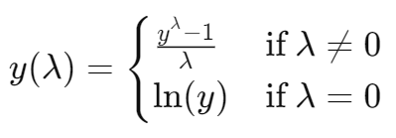
Where:
- y is the original data.
- λ is the transformation parameter.
- ln(y) is the natural logarithm of y.
The parameter λ determines the type of transformation applied to the data:
- λ=1: The data remains untransformed.
- λ=0: The data is transformed using the natural logarithm.
- λ=0.5: The data is square-root transformed.
- λ=−1: The data is transformed to its reciprocal.
2. When to Use the Box-Cox Transformation
- Non-Normal Data: When the data does not follow a normal distribution, especially when performing regression, ANOVA, or other parametric statistical tests.
- Skewed Data: When the data is highly positively or negatively skewed.
- Heteroscedasticity: When the variance of the residuals is not constant (heteroscedasticity). This transformation helps stabilize the variance.
- Linear Model Assumptions: When fitting a linear regression model, and the residuals violate the assumptions of normality, homoscedasticity, or linearity.
- Improving Model Fit: It is useful when you need to improve the fit of a model by transforming the response variable to a more suitable scale.
3. Why Use the Box-Cox Transformation
- Normality: Many statistical methods assume normality of the response variable, especially in linear regression. The Box-Cox transformation can make a variable more normally distributed.
- Stabilizing Variance: It helps in reducing heteroscedasticity (unequal variance across the data), which can improve the reliability of regression models.
- Improving Model Performance: By transforming the data, the model can better meet the assumptions of parametric statistical tests, potentially leading to more accurate and interpretable results.
- Dealing with Skewness: It effectively addresses both positive and negative skewness in the data.
4. How to Use the Box-Cox Transformation
Steps for Applying the Box-Cox Transformation:
- Identify the Variable to Transform: Apply the transformation to the dependent variable (Y) in your dataset.
- Choose the Optimal Lambda (λ): The value of λ is usually estimated using maximum likelihood estimation (MLE) to find the transformation that maximizes the likelihood of the data being normally distributed.
- Apply the Transformation: Once λ is determined, apply the transformation using the formula.
- Check the Results: After applying the transformation, check if the transformed variable is closer to a normal distribution by using statistical tests (e.g., Shapiro-Wilk test) or graphical methods (e.g., Q-Q plot.
5. Interpretation
- The estimated value of λ provides insight into the type of transformation applied.
  - λ=0: Logarithmic transformation.
  - λ=1: No transformation (data was already approximately normal).
  - λ>1: Indicates that the data requires a power transformation.
  - λ<0: Data may require a reciprocal transformation or inversion.
Transformed Data:
- After the transformation, the data should exhibit reduced skewness, stabilized variance, and improved normality.
- Residuals of the model (in the case of regression) should now satisfy the assumptions of normality and homoscedasticity.
Assessing Transformation:
- Q-Q Plot: Compare the transformed data to a normal distribution using a Q-Q plot. If the data points lie close to the line, the transformation worked.
- Residual Plots: After fitting the linear regression model, check the residual plots for homoscedasticity and normality.
6. Limitations of the Box-Cox Transformation
- Strictly Positive Data: The Box-Cox transformation requires that all values in the dataset be positive (y>0). If your data contains zero or negative values, a small constant must be added to all values before transformation.
- Interpretation of Results: Once the data is transformed, interpreting the coefficients of a regression model becomes more difficult because the original scale of the data has changed.
- Outliers: While the transformation can reduce skewness, it may not always handle extreme outliers effectively.
7. Alternatives to the Box-Cox Transformation
- Log Transformation: Directly apply the natural logarithm for data that is highly skewed, but contains no zeros or negative values.
- Yeo-Johnson Transformation: A modification of the Box-Cox transformation that can handle both positive and negative values in the dataset.
- Square Root Transformation: Useful for data that exhibits moderate skewness and includes small values.
- Reciprocal Transformation: For data with large positive skewness, the reciprocal transformation can be used (flips the values).

Does Box-cox always work? The answer is NO. Box-cox does not guarantee normality because it never checks for the normality which is necessary to be foolproof that it has correctly transformed the non-normal distribution or not. It only checks for the smallest Standard deviation.
Therefore, it is absolutely necessary to always check the transformed data for normality using a probability plot.
~~~~~~~~~~~~~~~~~~~~~~~~~~~~~~~~~~~~~~~~~~~~~~~~~~~~~~~~~~~~~~~~~~~~~~~~~~~~~~~~~~~~~~~
Box-Tidwell Transformation: Full Detailed Explanation
The Box-Tidwell transformation is a nonlinear transformation applied to the independent (predictor) variables in a regression model to check for and address nonlinearity between the independent variables and the dependent variable. This transformation is typically used in multiple linear regression to improve the fit of the model by transforming the predictors so they have a linear relationship with the response variable.
1. Mathematical Definition
The Box-Tidwell transformation is applied to continuous predictor variables to test whether the log-transformed values of the independent variables can better explain the variation in the dependent variable. The Box-Tidwell model takes the form:
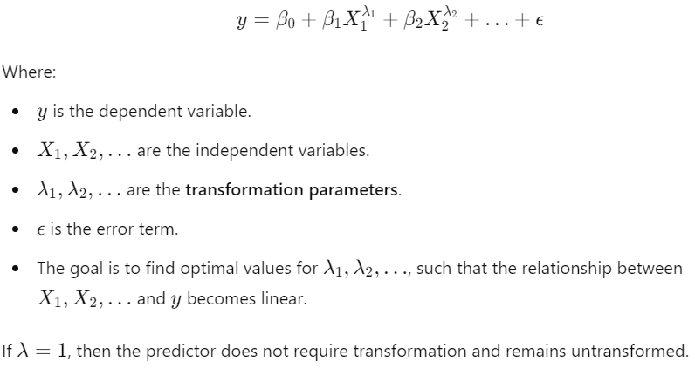
2. When to Use the Box-Tidwell Transformation
- Nonlinear Relationships: When the independent variables have a nonlinear relationship with the dependent variable. Box-Tidwell is applied to correct these nonlinearities and fit a better linear regression model.
- Checking Linearity Assumption: If you suspect that one or more predictors violate the linearity assumption of linear regression, the Box-Tidwell test can confirm if transformation is needed.
- Improving Model Fit: It is used to transform the independent variables so that the relationship with the dependent variable becomes more linear, leading to a more interpretable and accurate model.
3. Why Use the Box-Tidwell Transformation
- Linearity of Predictors: The Box-Tidwell test helps in checking whether continuous predictor variables satisfy the linearity assumption with the response variable.
- Transforming Nonlinear Predictors: The transformation ensures that the predictors contribute linearly to the model, improving the quality of the regression fit.
- Improving Model Assumptions: By transforming predictors that exhibit nonlinearity, the model's assumptions of linearity, normality, and homoscedasticity are better met, resulting in a more robust model.

4. How to Use the Box-Tidwell Transformation
Steps for Applying the Box-Tidwell Transformation:
- Identify the Predictors to Transform: Box-Tidwell is applied to continuous predictors where nonlinearity is suspected.
- Log Transformation: The independent variables are log-transformed and fitted into a regression model to test for linearity between the predictor and the response variable.
- Test for Linearity: For each predictor, the Box-Tidwell test computes the transformation parameter λ. If λ is significantly different from 1, the predictor should be transformed.
- Apply Transformation: If the test indicates that λ≠1\lambda \neq 1λ=1, you transform the predictor XXX using its optimal λ.
Interpretation of Results:
- If the transformation parameter λ is significantly different from 1 for any predictor, that predictor is nonlinearly related to the dependent variable and should be transformed.
- If the p-value associated with λ is small (e.g., less than 0.05), then a transformation of that predictor is necessary.
5. Interpretation of Box-Tidwell Results
Lambda (λ):
- λ=1: The predictor already has a linear relationship with the dependent variable and does not need transformation.
- λ≠1: The predictor has a nonlinear relationship with the dependent variable and should be transformed.
- Significant p-values: Suggest that the transformation parameter differs significantly from 1, meaning a nonlinear transformation is necessary.
Transforming the Predictors:
- After determining the appropriate transformation using Box-Tidwell, you can apply the transformation directly to the predictor variable.
- You will then re-fit the regression model using the transformed variable.
- Box-Tidwell Transformation Example
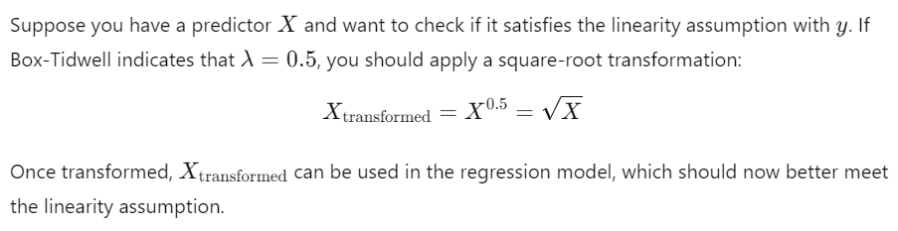
7. When Not to Use the Box-Tidwell Transformation
- Categorical Variables: Box-Tidwell is only for continuous predictor variables, so categorical predictors cannot be transformed using this method.
- Nonpositive Values: Like the Box-Cox transformation, the Box-Tidwell transformation requires that predictor values be positive. Negative or zero values will cause errors during the log-transformation.
8. Advantages and Limitations
Advantages:
- Improves Linearity: Helps ensure the predictor variables have a linear relationship with the response, improving model performance.
- Enhances Regression Model: By applying Box-Tidwell, the transformed predictors can better meet the assumptions of linear regression, making the model more reliable.
Limitations:
- Assumption of Positive Values: All predictors must have positive values, as the transformation involves the natural logarithm.
- Complex Interpretation: Once a predictor is transformed, the interpretation of the regression coefficients becomes more complex, as the variables are no longer on their original scale.
~~~~~~~~~~~~~~~~~~~~~~~~~~~~~~~~~~~~~~~~~~~~~~~~~~~~~~~~~~~~~~~~~~~~~~~~~~~~~~~~~~~~~~
If all categories are included, the design matrix X becomes linearly dependent, meaning one column can be written as a linear combination of others. This violates the assumption of no perfect multicollinearity in linear regression.
By dropping one category, we ensure that the design matrix is full rank, and each dummy variable now contributes unique information to the model.
~~~~~~~~~~~~~~~~~~~~~~~~~~~~ADDED VARIABLE PLOTS ~~~~~~~~~~~~~~~~~~~~~~~~~~~~~~~~~~~~~~~
Explanation of Added-Variable (Partial Regression) Plots
1. Purpose of Added-Variable Plots: An added-variable plot is a tool used to evaluate the importance of a predictor variable in a regression model, while considering the effect of other variables that are already included in the model. It helps answer the question: Does adding this new variable improve the model?
These plots are particularly useful because they show the marginal effect of a predictor—how it contributes to predicting the outcome, beyond what the other predictors already explain.

2. How Added-Variable Plots Work: Imagine you have two predictor variables in your model, X₁ and X₂. You want to know if X₁ really adds any value to predicting the outcome variable Y, given that X₂ is already in the model.
- Step 1: First, you regress Y on X₂ (i.e., fit a model with Y as the response and X₂ as the predictor). This gives you the residuals of Y after accounting for X₂. These residuals tell you what part of Y cannot be explained by X₂.
- Step 2: Similarly, you regress X₁ on X₂. This gives you the residuals of X₁ after accounting for X₂—the part of X₁ not explained by X₂.
- Step 3: Finally, you plot these two sets of residuals against each other. This plot shows how much of the remaining (unexplained) variation in Y can still be explained by X₁.

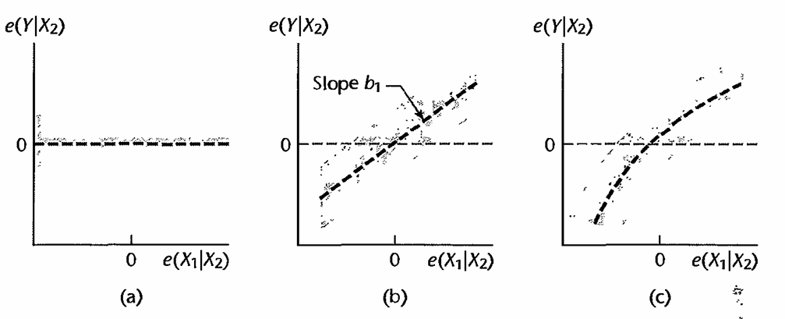
3. Interpreting the Plot: The way the points are arranged in the plot tells you about the role of X₁ in the model:
- Horizontal Line (No Slope): If the points form a horizontal line, it means X₁ doesn’t add any useful information to predict Y. Adding X₁ to the model wouldn’t improve it (Figure 10.1a).
- Linear Trend (With Slope): If the points form a straight line with a slope, it suggests that X₁ can improve the model by explaining some of the variation in Y that X₂ could not explain. The slope of this line is the coefficient of X₁ in the regression model (Figure 10.1b).
- Curved Pattern: If the points show a curved relationship, it indicates that X₁ has a more complex relationship with Y (perhaps a nonlinear relationship), which might require adding a squared or transformed version of X₁ to the model (Figure 10.1c).

4. Why Use Added-Variable Plots: These plots give two important pieces of information:
- Marginal Importance: They show whether adding a predictor (like X₁) reduces the residual variability, which indicates how important that predictor is.
- Shape of the Relationship: The plot can reveal if the relationship between the predictor and the outcome is linear, curved, or if the predictor adds no value.

5. Example with Two Predictors (X₁ and X₂): Imagine you are building a model to predict house prices (Y) based on the size of the house (X₁) and the number of bedrooms (X₂). If you already have the number of bedrooms in the model (X₂), the added-variable plot will show whether adding house size (X₁) helps explain price variations that are not captured by the number of bedrooms.
- If the plot shows a flat line, adding X₁ (house size) won’t help improve the model much.
- If the plot shows a sloped line, house size has an important impact on house price, even after considering the number of bedrooms.

6. Additional Information from the Plot:
- Reduction in Error: The steepness of the slope in the added-variable plot shows how much the predictor reduces the model's error.
- Outliers and Influence: These plots can also reveal outliers—data points that are unusual and may have an outsized influence on the model.

1. Nature of Relationships
- Added-variable plots can indicate how a predictor variable XkX_kXk​ might relate to the response variable YYY, but they do not give a precise mathematical expression of that relationship.
- These plots reflect the relationship of XkX_kXk​ after adjusting for the influence of other predictors in the model, rather than the direct relationship between XkX_kXk​ and YYY.
- To accurately model the relationship, you may need to explore various transformations or include terms that account for curvature effects (like polynomial terms) based on the plot results.
2. Caution with Interpretation
- Caution is advised when interpreting added-variable plots for predicting relationships. If the functional relationships among the predictor variables are misrepresented (e.g., if a curvilinear relationship is modeled as linear), the plots may not reflect the true nature of the relationships.
- If predictors are highly correlated, the plots might show misleading patterns. They also may fail to reveal any existing interactions between predictors that could be important.
3. Computational Efficiency
- When working with multiple added-variable plots, you don’t need to fit new regression models for each plot. Efficient computational techniques can help manage the calculations without starting from scratch each time.
4. Fitted Multiple Regression Function
- You can derive the fitted multiple regression function through a series of fitted partial regressions.
- For example, if you regress the residuals of YYY on one predictor against the residuals of that predictor on another predictor, you can express the fitted value of YYY using the coefficients from these regressions.
- This shows how the overall regression model can be constructed from simpler components, linking it back to the individual relationships between variables.
5. Partial Residual Plots
- Partial residual plots are similar to added-variable plots but provide additional information. They start with the usual residuals from a fitted model and add back the effect of the predictor variable of interest.
- This allows for a clearer understanding of the relationship for that specific predictor while accounting for the other variables in the model.

~~~~~~~~~~~~~~~~~~~~~~~~~~~~OUTLYING CASES~~~~~~~~~~~~~~~~~~~~~~~~~~~~~~~~~~~~~~~~~~~~
When more than two predictor variables are included in the regression model, however, the identification of outlying cases by simple graphic means becomes difficult because single-variable or two-variable examinations do not necessarily help find outliers relative to a multivariable regression model. Some univariate outliers may not be extreme in a mUltiple regression model, and, conversely, some multivariable outliers may not be detectable in single-variable or two-variable analyses.
Residuals and Semi studentized Residuals in Outlier Detection
In regression analysis, residuals and semistudentized residuals are key tools for identifying outlying observations. Here's a detailed explanation based on your except, which includes the hat matrix and its role in the analysis.
Residuals: Residuals are the differences between the observed values Yi​ and the predicted values Y^i​ from the regression model. They help in diagnosing the fit of the model.
Semistudentized Residuals: Semistudentized residuals adjust the ordinary residuals by their estimated standard deviation, allowing for a better comparison across observations. This adjustment accounts for the influence of each observation, particularly its leverage.
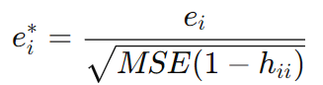
Key Insights for Outlier Detection
- Outlier Identification:
  - Residuals (both ordinary and semistudentized) are critical for identifying outliers in the response variable Y. High absolute values of semistudentized residuals indicate potential outliers.
- Leverage and Influence:
  - Observations with high leverage (high hii​) may disproportionately influence the fitted model. Monitoring the leverage can help identify points that may be affecting the model unduly.
- Correlation Among Residuals:
  - The covariance among residuals implies that pairs of observations can be related, which may complicate the interpretation of outliers.
- Model Diagnostics:
  - Proper diagnostics using residuals, semistudentized residuals, and the hat matrix can lead to improved model fitting by revealing model mis-specifications or the need for transformations.
~~~~~~~~~~~~~~~~~~~~~~~~~~~~~~~~~~~~~~~~~~~~~~~~~~~~~~~~~~~~~~~~~~~~~~~~~~~~~~~~~~~~~~~
Studentized Residuals: Studentized residuals are a refinement of the ordinary residuals, adjusted for their estimated standard deviations. They provide a standardized measure of the residuals, allowing for a more accurate assessment of outliers by accounting for varying variances across different observations.
Calculation of Studentized Residuals
- Residuals: The ordinary residual for observation iii is calculated as: ei​=Yi​−Y^i​
- Estimated Standard Deviation of Residuals: The standard deviation of the residual ei​ can be estimated using the Mean Squared Error (MSE) and the diagonal element of the hat matrix hii​:
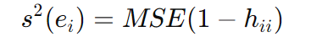
- Studentized Residual: The studentized residual rir_iri​ is then computed as:
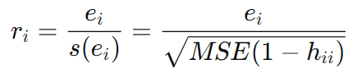
Properties of Studentized Residuals
- Constant Variance: Studentized residuals ri​ tend to have constant variance across all observations when the model is correctly specified. This property is essential for the reliable detection of outliers.
- Outlier Detection:
  - Observations with large absolute values of ri​ (typically greater than 2 or 3) may indicate potential outliers.
  - The use of studentized residuals helps mitigate the influence of observations with high leverage.
- Standardization: By standardizing the residuals, the studentized residuals allow for a fair comparison among observations, regardless of the variance in their residuals.
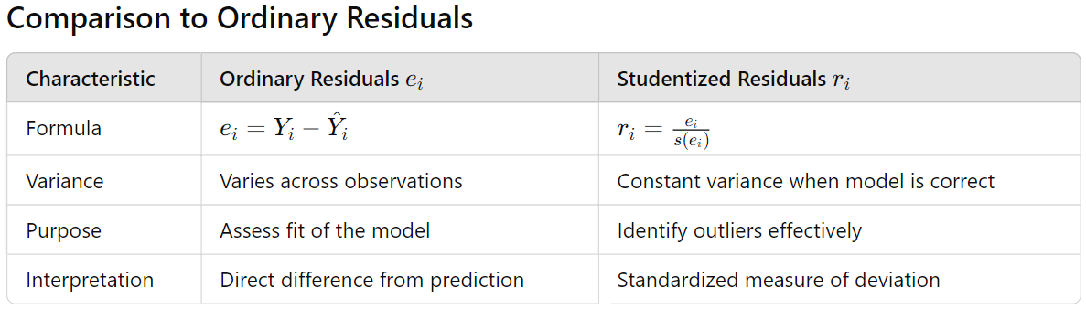
Importance in Regression Diagnostics
- Enhanced Outlier Detection: The studentized residuals provide a clearer indication of outliers compared to ordinary residuals, particularly in cases where variances differ significantly across observations.
- Model Diagnostics: Analyzing studentized residuals can reveal issues with model fit, such as non-linearity, omitted variables, or other specification errors.
- Robustness: Using studentized residuals allows for more robust regression diagnostics by controlling for the influence of high-leverage points.
~~~~~~~~~~~~~~~~~~~~~~~~~~~~~~~~~~~~~~~~~~~~~~~~~~~~~~~~~~~~~~~~~~~~~~~~~~~~~~~~~~~~~~~
Deleted Residuals
Purpose of Deleted Residuals: Deleted residuals are a refined way to identify outliers in regression analysis. They help determine if a particular observation (value of Y) is unusually high or low compared to what we expect, based on the other observations in the dataset.
How Deleted Residuals Work
The Problem with Ordinary Residuals:
- If an observation Yi​ is an outlier (very different from other values), it can influence the regression model. This means the predicted value Y
- ^i may be very close to Yi​, leading to a small residual ei​. In this case, the outlier doesn't get flagged, even though it should.
Using Deleted Residuals:
- To get around this issue, we can calculate the residual for an observation after removing it from the dataset. This means we fit the regression model to all other observations (leaving out the ith one) and then predict the value for the deleted observation.
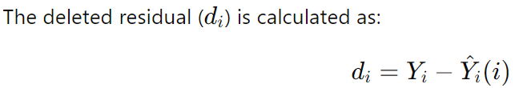
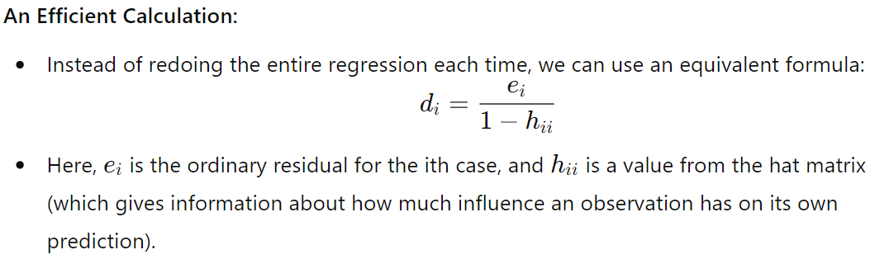-+-
Why Use Deleted Residuals?
- Deleted residuals provide a better indication of how outlying an observation is because they remove the bias that comes from fitting the model including that observation. If Yi​ is truly an outlier, the deleted residual di​ will tend to be larger than the ordinary residual ei​.
Identifying Outliers:
- Like studentized residuals, deleted residuals help in detecting outliers. A larger deleted residual suggests that the observation is different from what we expect based on the other data points.
~~~~~~~~~~~~~~~~~~~~~~~~~~~~~~~~~~~~~~~~~~~~~~~~~~~~~~~~~~~~~~~~~~~~~~~~~~~~~~~~~~~~
Studentized Deleted Residuals
Purpose of Studentized Deleted Residuals: Studentized deleted residuals combine the concepts of studentization and deleted residuals to provide a more accurate measure for detecting outlying or extreme values in regression analysis. They help assess whether a specific observation significantly deviates from the expected values based on the other observations.
How Studentized Deleted Residuals Work
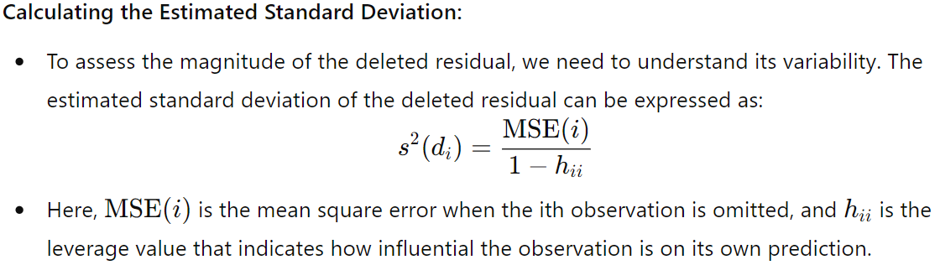
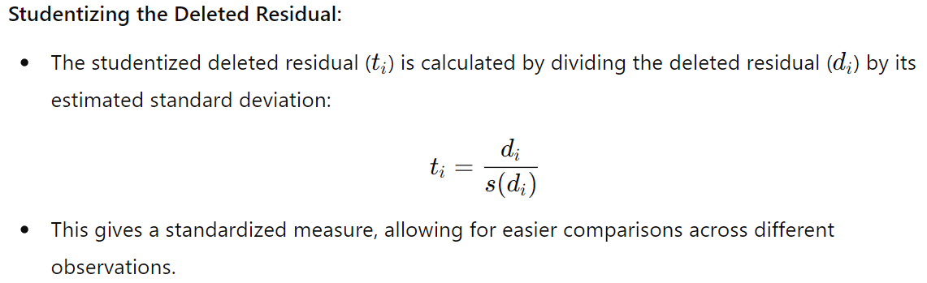
Understanding the T-Distribution:
- The studentized deleted residuals ti​ follow a t-distribution with n−p−1 degrees of freedom, where nnn is the number of observations and p is the number of predictors. This characteristic helps in statistical testing for outliers.
Efficiency in Calculation:
- One of the advantages of studentized deleted residuals is that they can be calculated without refitting the regression model multiple times. A relationship exists between the mean square errors (MSE) of the full model and the model with the ith observation deleted:
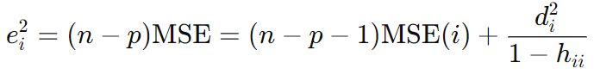
- Using this relationship allows for efficient calculation of tit_iti​ without repeated model fitting.
Final Expression:
- By substituting the values into the formula, we get an expression for the studentized deleted residual:
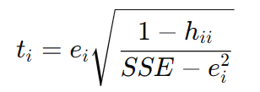
Test for Outliers: We identify as outlying Yobservations those cases whose studentized deleted residuals are large in absolute value. In addition, we can conduct a formal test by means of the Bonferroni test procedure of whether the case with the largest absolute studentized deleted residual is an outlier. Since we do not know in advance which case will have the largest absolute value |t|, we consider the family of tests to include n tests, one for each case. If the regression model is appropriate, so that no case is outlying because of a change in the model, then each studentized deleted residual will follow the t distribution with n - P - I degrees of freedom. The appropriate Bonferroni critical value therefore is t(1 - alpha/2n ; n - P - 1). Note that the test is two-sided since we are not concerned with the direction of the residuals but only with their absolute values.
~~~~~~~~~~~~~~~~~~~~~~~~~~~~~~~~~~~~~~~~~~~~~~~~~~~~~~~~~~~~~~~~~~~~~~~~~~~~~~~~~~~~~~~
Identifying Outlying X Observations Using Leverage Values
In regression analysis, identifying outlying X observations is crucial because such outliers can significantly affect the fitted model and its predictions. One effective way to detect these outlying observations is through leverage values, which are derived from the hat matrix.
Key Concepts
- Hat Matrix:
  - The hat matrix, denoted as H, transforms the vector of observed Y values into the vector of fitted Y values. Its diagonal elements, hii​, are particularly important for detecting leverage.
- Leverage Values:
  - Each diagonal element hii​ represents the leverage of the i-th observation concerning its X values.
  - The properties of leverage values include:
    - 0<hii​<1
    - The sum of all leverage values equals the number of parameters p in the regression model (including the intercept).
- Interpretation of Leverage:
  - A high leverage value indicates that an observation's X values are far from the center (mean) of the X values of all observations.
  - Observations with large leverage values can heavily influence the fitted regression model, making it important to identify them.
Identifying Outliers
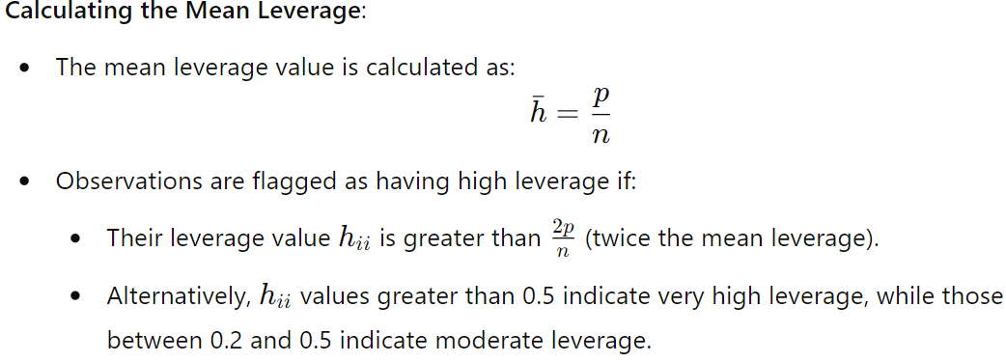
~~~~~~~~~~~~~~~~~~~~~~~~~~~~~~~~~~~~~~~~~~~~~~~~~~~~~~~~~~~~~~~~~~~~~~~~~~~~~~~~~~~~~~~
Influence on Single Fitted Value: DFFITS
DFFITS (Difference in Fits) is a valuable diagnostic measure used to assess the influence of an individual observation (case) on the fitted value in regression analysis. DFFITS quantifies how much the predicted value for an observation Yi​ changes when that specific observation is excluded from the model fitting
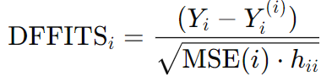
Influence Assessment: A larger absolute value of DFFITS indicates that the observation has a substantial influence on the fitted value, suggesting that it may be an outlier or influential data point.
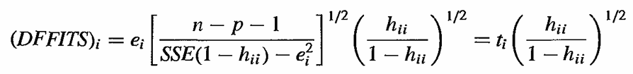
Key Insights
- Relationship to Studentized Deleted Residuals:
  - The expression shows that DFFITS is related to the studentized deleted residuals, adjusted by a factor influenced by the leverage value.
  - If case i has high leverage (i.e., is an outlier regarding X values), the DFFITS value will be larger in absolute terms.
- Guidelines for Identifying Influential Cases:
  - A common rule of thumb is to consider a case influential if 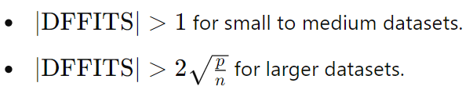
~~~~~~~~~~~~~~~~~~~~~~~~~~~~~~~~~~~~~~~~~~~~~~~~~~~~~~~~~~~~~~~~~~~~~~~~~~~~~~~~~~~~~~~
Influence on All Fitted Values: Cook's Distance
Cook's Distance (Di​) is a diagnostic measure used in regression analysis to assess the overall influence of an individual observation on all fitted values in a regression model. Unlike DFFITS, which focuses on the influence of a single case on its own fitted value, Cook's Distance evaluates how the inclusion or exclusion of that case affects the entire regression model.
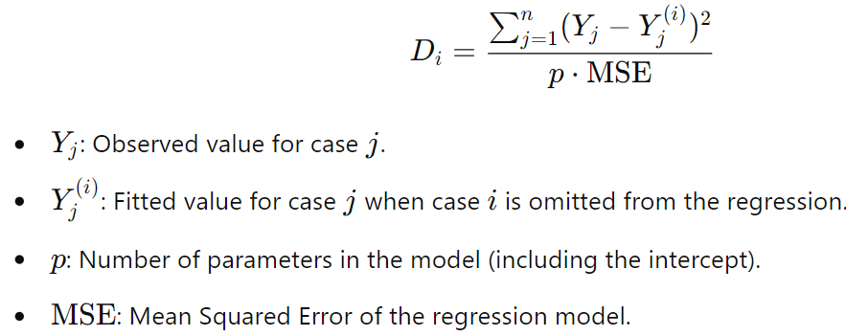
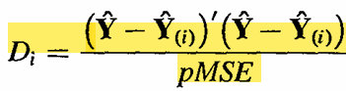
Interpretation
- Relationship to F-distribution:
  - To evaluate the influence of a case, Cook's Distance can be related to the F(p,n−p) distribution.
  - A percentile value below 10-20% indicates that the case has little influence, while values around 50% or more suggest significant influence on the fitted values.
- Components of Cook's Distance:
  - The expression can also be calculated without refitting the model using:
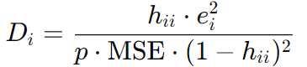
Influence Factors:
- The influence of the i-th case can stem from:
  - A large residual ei​ with a moderate leverage hii​.
  - A large leverage hii​ with a moderate residual ei​.
  - Both a large residual and a large leverage.
~~~~~~~~~~~~~~~~~~~~~~~~~~~~~~~~~~~~~~~~~~~~~~~~~~~~~~~~~~~~~~~~~~~~~~~~~~~~~~~~~~~~~~~
Influence on the Regression Coefficients: DFBETAS
DFBETAS is a diagnostic measure used in regression analysis to assess the influence of a specific observation (case) on each regression coefficient (bk​). It helps identify how much a case affects the estimated coefficients when included in the model compared to when it is omitted.
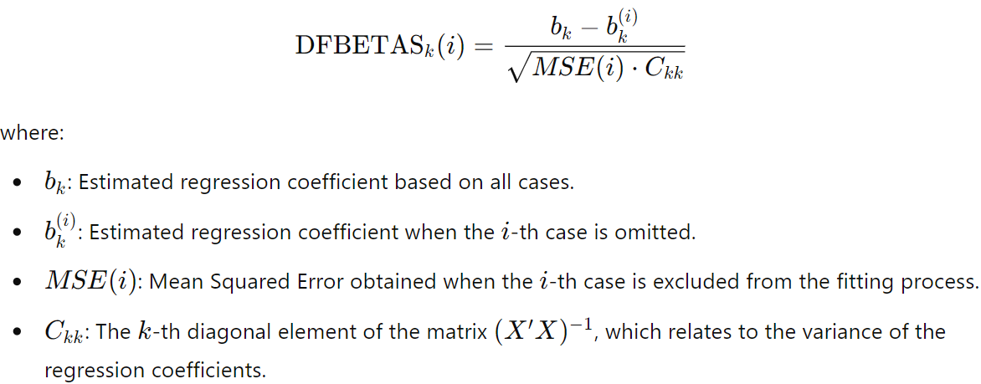
Interpretation
- Direction of Influence:
  - The sign of DFBETAS indicates whether the inclusion of case i increases (positive sign) or decreases (negative sign) the estimated regression coefficient bk​.
- Magnitude of Influence:
  - The absolute value of DFBETAS measures the impact of the i-th case on the k-th coefficient relative to its estimated standard deviation. A larger absolute value indicates a more substantial influence.
- Guidelines for Identifying Influential Cases:
  - A case is considered influential if:

Relationship Between Cook's Distance and the Influence on Regression Coefficients
Cook's Distance (Di​) serves as a comprehensive measure of influence in regression analysis, reflecting the impact of an individual case on all fitted values and regression coefficients simultaneously. This relationship underlines the utility of Cook's Distance as an aggregate influence diagnostic.
Derivation and Equivalence
- Confidence Region for Regression Coefficients:
  - The boundary of the joint confidence region for the estimated regression coefficients (βk​) in a normal error multiple regression model can be expressed as:
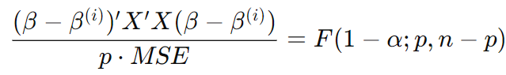
- This expression provides a statistical framework for assessing how much the coefficients vary when an individual case is omitted.
Cook's Distance as an Aggregate Influence Measure:
- Cook's distance can be represented in a similar mathematical form:
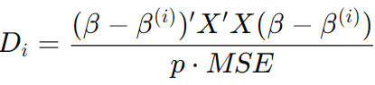
Here, β(i) is the vector of estimated regression coefficients when the i-th case is omitted, and β is the vector when all cases are included.
Algebraic Identity
- The expressions for Cook's Distance in both representations are algebraically identical, indicating that Cook's Distance encapsulates the aggregate influence of the iii-th case on the fitted values and regression coefficients simultaneously.
Implications
- Aggregate Influence:
  - Cook's Distance effectively summarizes the cumulative impact of an observation across all fitted values and regression coefficients, making it a powerful diagnostic tool in regression analysis.
- Identification of Influential Cases:
  - By evaluating Cook's Distance, analysts can identify cases that exert a disproportionately large influence on the model, whether through their residuals or leverage.
- Joint Confidence Regions:
  - The derivation from joint confidence regions enhances the theoretical foundation of Cook's Distance, establishing it as a robust measure for understanding the effects of individual data points within a regression framework.
~~~~~~~~~~~~~~~~~~~~~~~~~~~~~~~~~~~~~~~~~~~~~~~~~~~~~~~~~~~~~~~~~~~~~~~~~~~~~~~~~~~~~~~
Question: What methods are recommended for analyzing different types of outliers in regression analysis, including influential outliers, leverage points, response variable outliers, coincidental outliers, and high-residual points?
- Influential Outliers:
  - Cook's Distance: Assesses overall influence on fitted values.
  - DFBETAS: Measures influence on individual regression coefficients.
  - DFFITS: Evaluates influence on individual fitted values.
- Leverage Points:
  - Leverage Statistics (hii): Identifies high leverage cases.
  - Studentized Residuals: Assesses effect of leverage on residuals.
- Response Variable Outliers:
  - Standardized Residuals: Identifies cases with extreme residuals.
  - Boxplots: Visualizes potential outliers in the response variable.
- Coincidental Outliers:
  - Multi-Case Deletion: Analyzes combined influence of clustered cases.
  - Resampling Techniques: Evaluates model stability with multiple influential points.
- High-Residual Points:
  - Residual Analysis: Identifies and evaluates large residuals.
  - Influential Case Diagnostics: Uses Cook's Distance and DFFITS for impact assessment.
A combination of these methods provides a comprehensive understanding of outliers and their effects on regression models, leading to more reliable analyses.
~~~~~~~~~~~~~~~~~~~~~~~~~~~~~~~~~~~~~~~~~~~~~~~~~~~~~~~~~~~~~~~~~~~~~~~~~~~~~~~~~~~~~~~
(Leverage and influence points).
• A leverage point is an observation that has an unusual predictor value (very different from the bulk of the observations).
• An influence point is an observation whose removal from the data set would cause a large change in the estimated regression model coefficients.
A leverage point may have no influence if the observation lies close to the regression line. A point has to have at least some leverage in order to be influential
~~~~~~~~~~~~~~~~~~~~~~~~~~~~~~~~~~~~~~~~~~~~~~~~~~~~~~~~~~~~~~~~~~~~~~~~~~~~~~~~~~~~~~~
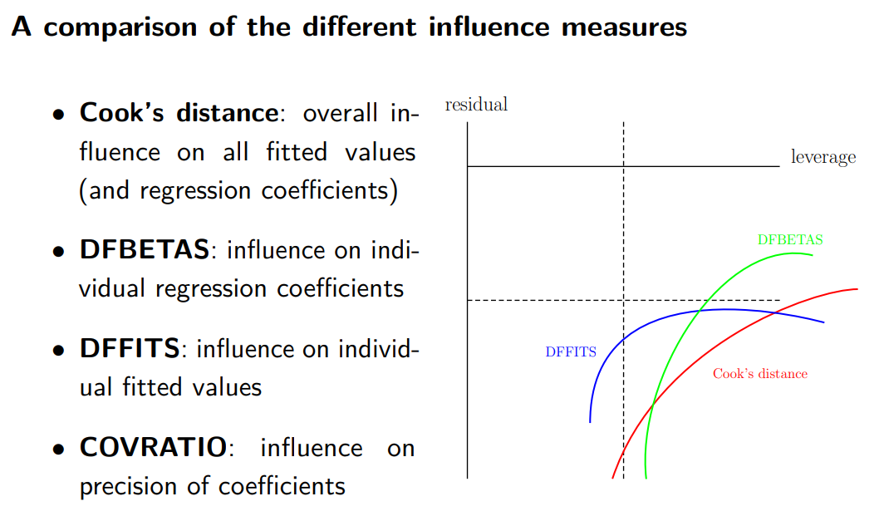
Groups of influential observations
The discussion of which points constitute leverage or influential points can be extended to groups of two or more points in a similar way.
For example, Cook’s distance measure can be extended to assess the simultaneous influence of a group of m points - simply leave out all m points simultaneously and re-calculate the regression parameters. There can be situations in which several data points are jointly influential, while individual points are not.
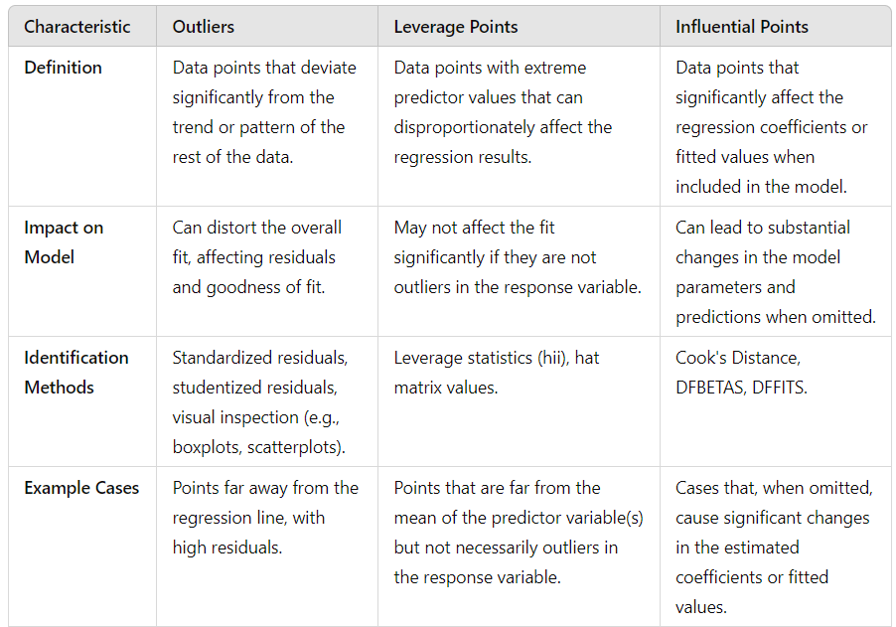
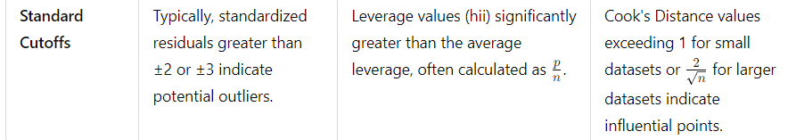
Criteria for Model Selection:
Mallows'Cp​ Criterion
Mallows' Cp​ criterion is a way to evaluate regression models by measuring their total error. This error can be broken down into two parts: bias (how far the model's predictions are from the true values) and random error (variation due to randomness in the data).
Here’s how it works, step-by-step:
- Total Error: When you fit a regression model, the predicted values may not perfectly match the true values. The total error in a prediction comes from two sources:
  - Bias: This happens when the model's predictions are systematically off from the true values. In simple terms, if the model is wrong (for example, missing an important predictor), its predictions will be biased.
  - Random Error: This is the natural variation in the data. Even if the model is correct, the data itself can fluctuate due to randomness.
- Mean Squared Error (MSE): The mean squared error for each prediction measures the total error, which includes both the bias and the random error. The goal is to have a model where the MSE is as low as possible, meaning the predictions are close to the true values.
- Total Mean Squared Error: For the entire model, the total mean squared error is just the sum of the MSE for all predictions. If a model has a small total MSE, it means that both the bias and random error are low, so the model fits well.
- The Cp​ Formula: Mallows' Cp​ takes this total mean squared error and adjusts it for the number of predictors (variables) in the model. It’s designed to:
  - Keep the model simple (avoid too many predictors, which could lead to overfitting).
  - Ensure the model has small error.
The formula is:
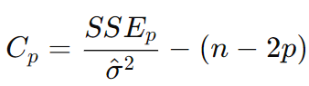
- Choosing the Best Model Using Cp​:
  - You want a model where the Cp​ value is close to p, which suggests that the model has low bias and small total error.
  - If the Cp​ value is much larger than p, it indicates that the model has too many predictors, leading to overfitting.
  - If the Cp​ value is smaller than p, it might be because of sampling error, not necessarily because the model is better.
- Graphical Interpretation: When you plot the Cp​ values for different models (with varying numbers of predictors), you look for the models where Cp​ is near the line Cp​=p. Models falling near this line are considered good because they balance simplicity and accuracy. Models falling far above the line have too much bias, while those below the line might just be due to random variations in the data.
Key Points to Remember:
- Small Cp​ value: Good, the model has low total error.
- Cp​ near p: The model has low bias, meaning it is a good fit.
- Overfitting: If Cp​ is much larger than p, the model might be overfitting (using too many predictors).
- Underfitting: If the model has a small number of predictors and a small Cp​, it might be underfitting (not capturing enough details).
Simple Example:
Imagine you are trying to predict house prices. You have 10 different features (like the number of bedrooms, size, location, etc.). You want to find the best model that uses some of these features, but not all of them, to avoid making the model too complex.
For each subset of features (like 2 features, 3 features, etc.), you calculate the Cp​ value. The best model will have a Cp​ value close to the number of features (i.e., close to 2 for a 2-feature model, close to 3 for a 3-feature model, and so on). The one with small Cp​ and Cp​ near the number of features is the best choice.

Why Mallows' Cp​ Should Be Close to p
Mallows' Cp​ criterion is a method for selecting a regression model by evaluating its fit and complexity. Here’s why the Cp​ value should be close to p (where p is the number of predictors in the model):
1. Low Bias, Good Fit
When Cp​ is close to p, it indicates that:
- The model is unbiased (the bias is low).
- It fits the data well without overcomplicating the model.
The formula for Cp​ includes the total error (bias + random error), and when this error is minimal, it means the model is neither missing important predictors nor including unnecessary ones. A Cp​ near p reflects that the model captures the underlying pattern in the data without introducing too much error from missing predictors.
2. Avoiding Overfitting
If Cp​ is much larger than p, this suggests that the model is overfitting. Overfitting happens when the model becomes too complex, fitting the random noise in the data rather than the true underlying relationship. A large Cp​ implies that the model may have included too many predictors, leading to poor generalization to new data.
By keeping Cp​ close to p, you ensure that the model remains simple enough to generalise well but complex enough to explain the data accurately.
3. Penalty for Complexity
Mallows' Cp​ also penalises for complexity by considering the number of predictors p. If the model becomes too complex, the Cp​ value rises above p, signalling that a significant reduction in the total error does not justify the added complexity. A model where Cp​ ≈ p balances this trade-off between error and complexity.
4. Good Subset Selection
When selecting a subset of predictors, models where Cp​ is close to p are preferred because they indicate that the subset of predictors is a good representation of the full model (which contains all predictors). This means that these models do not suffer from underfitting (too few predictors) or overfitting (too many predictors).
~~~~~~~~~~~~~~~~~~~~~~~~~~~~~~~~~~~~~~~~~~~~~~~~~~~~~~~~~~~~~~~~~~~~~~~~~~~~~~~~~~~~~~~
Akaike Information Criterion (AIC)
The Akaike Information Criterion (AIC) is a widely used statistical measure for model selection, particularly in the context of regression analysis, time series analysis, and machine learning. AIC is designed to provide a balance between model fit and model complexity, helping to identify the best model among a set of candidates.
Key Concepts
- Model Fit vs. Complexity:
  - AIC aims to quantify how well a model fits the data while penalizing for the number of parameters. This helps to avoid overfitting, where a model might fit the training data very well but perform poorly on new, unseen data.
- Likelihood Function:
  - AIC is derived from the likelihood function, which measures the goodness of fit of a statistical model. It essentially assesses how likely the observed data is under a particular model.
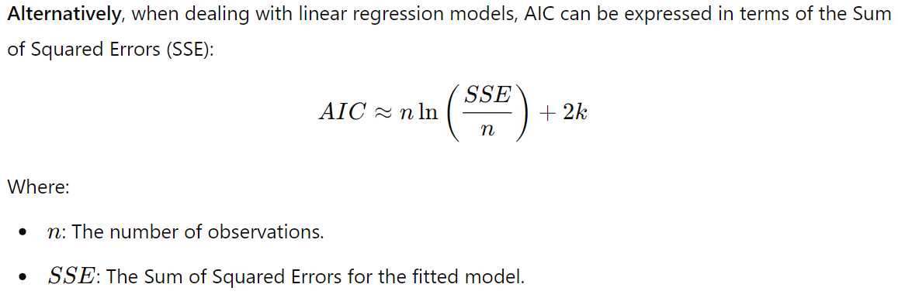
Interpreting AIC Values
- Lower AIC values indicate a better model fit, balancing the goodness of fit against model complexity.
- When comparing multiple models, the one with the smallest AIC value is considered the best.
- AIC does not provide an absolute measure of the model quality; it is useful for comparing models relative to each other.
Applications of AIC
- Model Selection: AIC is commonly used in regression analysis, time series analysis, and machine learning for selecting the most appropriate model from a set of candidates.
- Comparing Non-Nested Models: AIC can be applied to compare models that are not necessarily nested, providing flexibility in model selection.
- Cross-Validation: AIC can be used alongside other metrics like BIC (Bayesian Information Criterion) and cross-validation techniques to enhance the robustness of model selection.
Advantages of AIC
- Simplicity: AIC is straightforward to calculate and easy to interpret.
- Flexibility: It can be applied to various statistical models, including linear and nonlinear regression, time series, and machine learning models.
- Balanced Approach: It provides a balance between goodness of fit and complexity, making it effective in preventing overfitting.
Disadvantages of AIC
- Not Absolute: AIC values are not absolute; they are only meaningful in the context of model comparison.
- Assumes Correct Model Form: AIC assumes that the true model form is within the candidate set. If none of the models are appropriate, AIC may lead to incorrect selections.
- Sensitive to Sample Size: For small sample sizes, AIC may favor more complex models. In such cases, BIC or SBC might be preferred due to their stricter penalties.
~~~~~~~~~~~~~~~~~~~~~~~~~~~~~~~~~~~~~~~~~~~~~~~~~~~~~~~~~~~~~~~~~~~~~~~~~~~~~~~~~~~~~~~
Bayesian Information Criterion (BIC)
The Bayesian Information Criterion (BIC), also known as the Schwarz Bayesian Criterion (SBC), is a widely used statistical method for model selection, similar to the Akaike Information Criterion (AIC). BIC provides a means to evaluate the trade-off between model fit and complexity, helping researchers choose the most appropriate model from a set of candidates.
Key Concepts
- Model Fit vs. Complexity:
  - Like AIC, BIC seeks to balance how well a model fits the data against the number of parameters it uses. BIC penalizes model complexity more strongly than AIC, particularly in larger datasets.
- Likelihood Function:
  - BIC is derived from the likelihood function, which measures the goodness of fit of a statistical model to the observed data.
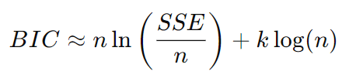
Advantages of BIC
- Stronger Penalty: BIC imposes a stronger penalty for complexity compared to AIC, making it more conservative in model selection, especially for larger datasets.
- Flexibility: BIC can be applied to various statistical models, including linear and nonlinear regression, time series, and machine learning models.
- Interpretability: The BIC formula is intuitive and straightforward to interpret.
Disadvantages of BIC
- Not Absolute: Similar to AIC, BIC values are not absolute; they only make sense in the context of model comparison.
- Assumes Correct Model Form: BIC assumes that the true model is within the candidate set. If none of the models are appropriate, BIC may lead to incorrect selections.
- Sensitivity to Sample Size: The penalty term in BIC increases with sample size, which can lead to the selection of simpler models in large datasets.
Comparison of AIC and BIC
- Penalty for Complexity: AIC uses a penalty of +2k, while BIC uses +klog(n). As a result, BIC tends to prefer simpler models compared to AIC, especially as the sample size increases.
- Focus: AIC is generally more focused on prediction accuracy, while BIC emphasizes model parsimony and the likelihood of the true model being included in the candidate set.
- Use Cases: AIC is often favoured when prediction is the primary goal, while BIC may be preferred in scenarios where identifying the true underlying model is essential.
~~~~~~~~~~~~~~~~~~~~~~~~~~~~~~~~~~~~~~~~~~~~~~~~~~~~~~~~~~~~~~~~~~~~~~~~~~~~~~~~~~~~~~
Need for BIC When AIC Exists: Both the Akaike Information Criterion (AIC) and Bayesian Information Criterion (BIC) are used for model selection, but they have different underlying philosophies and penalization mechanisms. Here are several reasons why BIC is also necessary and useful alongside AIC:
1. Different Penalty for Complexity
- AIC: Applies a penalty +2k, where k is the number of parameters. This penalty is relatively lenient, which can sometimes lead to the selection of more complex models, particularly in smaller datasets.
- BIC: Applies a penalty of +klog(n), where n is the sample size. This penalty increases with sample size, making BIC more conservative. It tends to favour simpler models, especially as the number of observations grows.
2. Different Use Cases
- AIC: Often used in scenarios where prediction is the primary goal, such as in machine learning or situations where forecasting accuracy is paramount.
- BIC: More suitable when the goal is to identify the true underlying model, especially in a Bayesian context. It's particularly helpful when the sample size is large and when the risk of overfitting needs to be minimized.
3. Model Stability and Interpretability
- BIC's stricter penalty: Makes it less likely to select overly complex models, resulting in more interpretable models that are easier to understand and explain. This is important in fields where model interpretability is crucial, such as healthcare or social sciences.
4. Complementary Insights: Using both AIC and BIC can give us helpful insights when choosing a model.
- A model chosen by AIC may be more adaptable and work better for making predictions.
- On the other hand, a model chosen by BIC is likely to be simpler and more reliable for understanding the key relationships in the data.
By looking at both AIC and BIC, we can get a clearer picture of which model is best for our needs.
~~~~~~~~~~~~~~~~~~~~~~~~~~~~~~~~~~~~~~~~~~~~~~~~~~~~~~~~~~~~~~~~~~~~~~~~~~~~~~~~~~~~~~~
PRESS Criterion:
The PRESS (Prediction Sum of Squares) Criterion is a statistical measure used to evaluate how well a regression model predicts the observed values based on a subset of the data. It focuses on the prediction accuracy of the model by assessing the sum of squared differences between actual responses and predicted values, where the predictions are made by leaving out each observation one at a time.
How is the PRESS Criterion Used?
- Model Evaluation: The PRESS criterion is used to assess the predictive performance of regression models. A lower PRESS value indicates a model that predicts better.
- Omission of Cases:
  - For each observation in the dataset, the PRESS criterion involves the following steps:
    - Omit the i-th observation from the dataset.
    - Fit the regression model using the remaining data.
    - Predict the response for the omitted observation using the fitted model.
- Calculation:
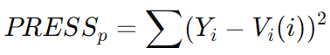
- Comparison of Models: By calculating PRESS values for different models, researchers can compare which model provides better predictions. Models with lower PRESS values are generally preferred.
- Avoiding Overfitting: The PRESS criterion helps identify models that generalize well to new data, thus reducing the risk of overfitting.
When to Use the PRESS Criterion?
- Model Selection: When choosing between multiple regression models, especially when there's a concern about overfitting.
- Validation: As part of the model validation process to ensure that the model performs well on unseen data.
~~~~~~~~~~~~~~~~~~~~~~~~~~~~~~~~~~~~~~~~~~~~~~~~~~~~~~~~~~~~~~~~~~~~~~~~~~~~~~~~~~~~~~~
Interaction Terms in Regression
Interaction terms are used in regression to capture the combined effect of two or more predictor variables on the response variable, beyond their individual effects.
Why We Need Interaction Terms
In many real-world scenarios, the effect of one predictor variable on the response may change depending on the value of another predictor variable. Interaction terms help model these dependencies.
1. Real-World Dependencies:
- Sometimes, two variables influence each other in a way that their combined effect on the target is not simply additive.
- Example: In a sales prediction model, both price and advertising may affect sales, but price changes may have a different effect depending on how much is spent on advertising.
2. Improved Model Accuracy:
- Including interaction terms often improves the model's accuracy because it can account for more complex relationships that would otherwise be missed.
- Without interaction terms, the model might underperform or fail to capture certain patterns in the data.
3. Hypothesis Testing:
- Interaction terms allow you to test specific hypotheses about whether the relationship between two predictors impacts the outcome differently when they occur together.
4. Non-linearity:
- When interaction terms are introduced, they can capture non-linear relationships between predictors and the outcome.
- Interaction can sometimes mimic non-linear effects when the individual terms do not suffice.
Examples:
1. Marketing: Price and Advertising
Scenario: A company wants to predict sales based on price and advertising expenditure.
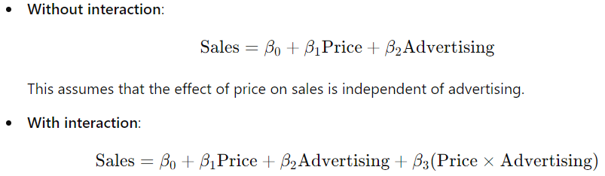
Interpretation: If the interaction term is significant, it means that the effect of price on sales depends on how much is spent on advertising. For example:
  - When advertising expenditure is high, lowering the price might lead to substantially higher sales.
  - When advertising is low, price reductions might not have a large impact.

2. Health: Smoking and Exercise
Scenario: A study aims to predict the risk of heart disease based on smoking habits and exercise frequency.
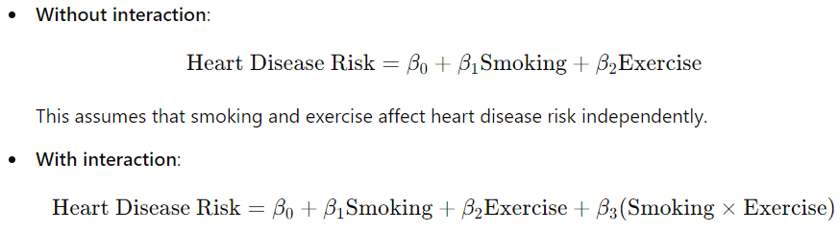
Interpretation: The interaction term captures the fact that smoking may increase heart disease risk much more for those who don’t exercise. For example:
  - The risk for smokers who don’t exercise may be far higher than the sum of the risks for smoking and lack of exercise separately.

3. Education: Study Hours and Tutor Help
Scenario: A school wants to understand the effect of hours spent studying and tutoring sessions on students’ exam scores.
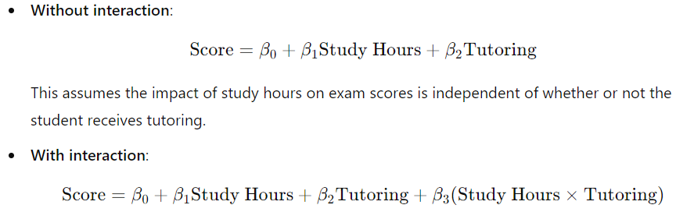
Interpretation: If the interaction term is significant, it indicates that the effect of studying on exam scores depends on whether or not a student receives tutoring. For instance:
  - Tutoring might amplify the effect of study hours on scores, where students who both study more and receive tutoring perform better than expected based on individual effects of studying or tutoring alone.

4. Medicine: Drug Dosage and Age
Scenario: A pharmaceutical company is studying the impact of drug dosage and age on a patient's response to a new treatment.
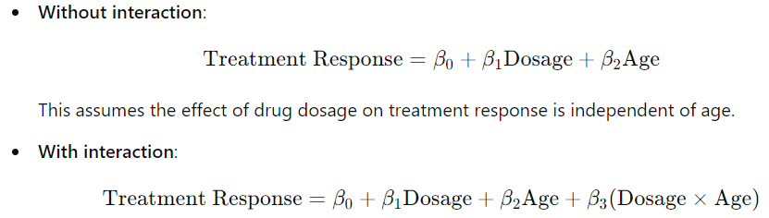
Interpretation: If the interaction is significant, it shows that the effect of dosage on treatment response depends on the patient's age. For example:
  - Older patients may require a lower dosage for the same effect due to slower metabolism, whereas younger patients may need higher doses for optimal response.
~~~~~~~~~~~~~~~~~~~~~~~~~~~~~~~~~~~~~~~~~~~~~~~~~~~~~~~~~~~~~~~~~~~~~~~~~~~~~~~~~~~~~~~
